Please fill out the following information:
Note: This information will be used as the main contact for anyone purchasing on your fundraising site
Contact Person: | Phone Number:
Email: | Address:
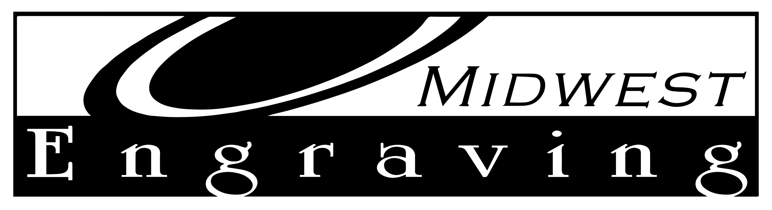 EZEngraver Setup Guide

We are thrilled you have chose Midwest Engraving for your paver fundraiser! This form will help guide us in creating your custom fundraising website. It is very detailed so fill it out to the best of your knowledge and we can make any final touches after your first look!
Organization Information

Logo: (please send high quality image to mwengr@aol.com Attn: Emily for Online Setup) This will be displayed as the logo for the fundraising website
Website Colors: Please choose 2 colors from the selection below – 1 from darker section & 1 from the lighter section
Darker Colors: |  | Black | Gray | Brown |  | Tan | Maroon | Orange | Green |  | Turquoise |  |  | Teal |  | Blue | Purple |  | Pink
 | Lighter Colors: | White | Silver |  | Tan |  | Red | Orange |  | Gold |  | Yellow | Green |  | Turquoise |  |  | Blue |  | Purple | Pink
Brick Information
Paver Color: | Admiral Red | Landmark Gray | Nutmeg | Regimental Red
Font: (ex. below) | Caslon | CG | Goudy | Vermarco

Project Information: (will be displayed on main page)*

About Page: (optional)

Gallery: (optional) provide photos of where the bricks are going, sample engraved paver, etc. Attach photos to email with logo
Your Website Url:

Symbols
If you are thinking of adding some personality to your paver project consider adding a symbol/emblem or logo! Below you will see a sample of our artwork. You can request our symbol catalog for a larger preview or check it out on our website at www.midwestengraving.com/images/symbolsmidwestengraving.pdf.
Symbol Selection: (put ID #’s here, up to 10 logos) | Are you allowing logos? Yes or No

Brick Sizes
Paver Size: | 4x8 | 8x8 |  | Combination of Both Sizes
Are you using Limestone or Granite? If YES |  |  | 12x12 Limestone |  | 16x16 Limestone
 |  |  | 12x12 Granite |  | 16x16 Granite
Selling Prices for Each Paver Size – Fill in Customer Pricing Below
4x8 | $ Fill in price here |  |  |  |  | 4x8 with a symbol |  | $ Fill in price here
8x8 | $ Fill in price here |  |  |  |  | 8x8 with a symbol |  | $ Fill in price here
8x8 with Logo | $ Fill in price here |  |  |  |  | 12x12 Limestone |  | $ Fill in price here
12x12 Granite | $ Fill in price here |  |  |  |  | 16x16 Limestone |  | $ Fill in price here
16x16 Granite | $ Fill in price here
Note: If you are allowing logos for your organization please note that your organization is responsible for collecting logos from your brick sponsors. Request a black and white crisp outline logo (no gray scale, color, scans or copies) and submit them as a .jpg, .eps, .pdf. to Midwest Engraving and we will provide a proof prior to engraving.

Payment Information

When using the EzEngraver website, we process credit cards securely using a website called stripe. Please visit their website (https://dashboard.stripe.com/register) and sign up for an account. Once you have completed your activation you will need to provide the following LIVE keys to Midwest. Email to mwengr@aol.com subject: stripe set up
*Midwest Engraving does not manage or view your stripe account. You will work directly with stripe.com
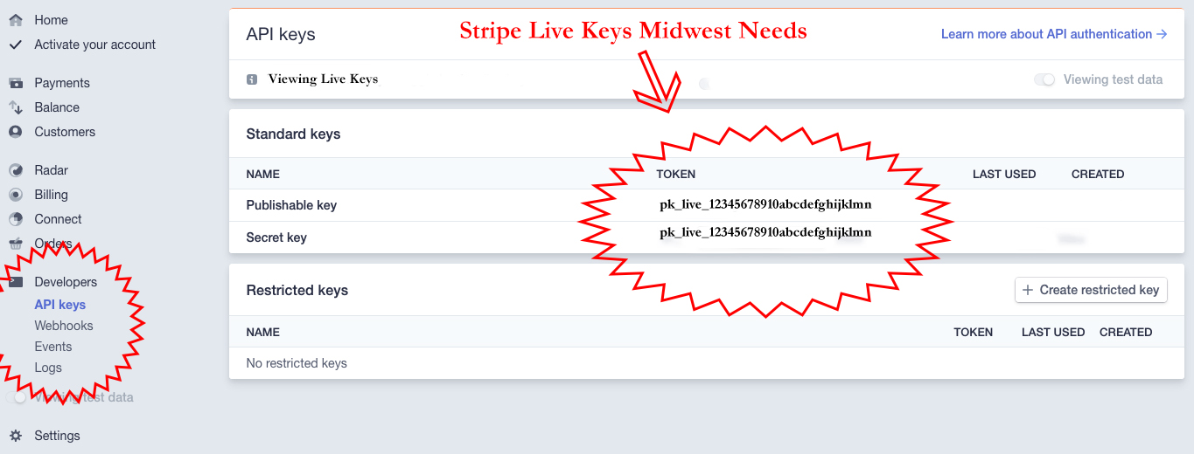
Stripe Live Keys: | Publishable Key: pk_live_
 | Secret Key: pk_live_
Next Step

We look forward to helping you with your engraved brick fundraiser! Once we receive this information from you, we will start building your site! This process goes pretty quick and your website will be live soon.

Within a few days, Midwest will be sending over your unique website URL (if you have a website URL you like please provide here: __________), admin login and password. We also provide a document on how to work the backend of the website (it is very simple & easy might I must note). Keep this on hand for when you receive your first order!

Please direct all website questions to Emily Peace at 330-334-1988. All other brick questions can be answered directly with Linda at 330-334-2572.

